Contributed Article
Publication: Video/Imaging Designline
Due date: 12/22

Strategies and Considerations for Optimizing File-Based Video Quality Control
By Jon P. Hammarstrom, Tektronix
Storing and manipulating file-based video and audio provides tremendous speed, flexibility and cost savings and has revolutionized content delivery in many ways. But as many different files and formats in various states of compression and aspect ratios pile up in the operations centers, issues around quality control and workflow have begun to take center stage. Whether for broadcast or content on-demand audiences, the need to optimize the quality control (QC) process of file-based video content has become a critical requirement.

The consumer’s perception of quality is a key factor in the differentiation between content providers. Ensuring and optimizing file-based content quality requires providers to have the ability to evaluate and manage media quality within internal networks and to accurately assess the impact their media content can have on other elements in the ecosystem. It is not just the audio, video and metadata that matter any more; format and syntax are critical as well.
Throughout the video delivery chain, participants are upgrading their workflow to support all digital environments. But because more and more content is compressed and archived in one format and then repurposed to another format, archives are far from homogenous, and maintaining control over output presents a significant challenge. In this article we will examine issues facing engineers and managers who must deal with quality control of file-based content.
The High Cost of Spot Checking
There are many reasons to check file-based quality at a number of stages throughout the video delivery process. Even if you begin with high quality video, compression and transcode failures at any point may cause transfers to stall, set top decoders to crash or even dead air to occur. Spot checking, while useful for identifying systemic problems, leaves the door open for costly problems on a fairly regular basis. While every business is different, here is a partial list of areas that can result in lost revenue or worse:
- Missed commercials leading to refunds or “free” replacements
- Brand cost of transmitting poor quality content
- Dead air time
- Refunds for poor-quality downloads
- Rejected content
- Opportunity cost of answering/fixing problem after they have occurred

Visual Inspection – No Longer Enough
For many organizations the most common approach to QC has been to have a small staff of people visually review the content. Even with a waveform monitor, these visual inspection checks are subjective and costly, especially as the volume of content increases.
Realistically, QC staff can only be counted on for two main categories of technical impairments:
- Analog parameters of signal levels, like luma and chroma levels
- Quality levels like black sequences, freeze frame, blockiness, loss of audio, video and audio playtime
The visual inspection approach has proven reasonably effective when reviewing relatively small volumes of video content. But regardless of the strength of the QC staff, there are human factors to be considered regarding visual inspection:
- Visual and audio errors are easily missed, just by blinking or losing concentration for a second.
- Reviewers have a range of skill levels, experience and training resulting in considerable differences among errors found by different observers.
- Staying objective can be difficult, especially over long periods of time, even while viewing similar content.
- Some content may have special considerations (e.g. adult entertainment).
- It is tiring to people doing visual inspection, day after day, week after week.
- Equipment used in visual inspection may differ by QC station or site, leading to inconsistent results.
Taking this a step further, a human cannot easily look inside the file at the detail level. This is where automated systems come into play to detect the kinds of problems that occur in file-based video when something isn’t quite right. These can include:
- Incorrect play time — measured with frame accuracy.
- Putting the audio on the incorrect channels (or omitted altogether).
- The wrong format of the content has been provided.
- Incorrect stream setup (e.g. three seconds of audio silence is required at the start but is not present).
- Compliance to various industry de-facto standards. The stream is correct and legal, but still not what the client needs (e.g. H.264 instead of MPEG2).
- Missing required data for closed captioning.
- Transport Stream and multiplexing errors.
- Missing metadata used by an automation system.
- Incorrect bit rate for the video or audio.
- Encoding quality errors, where the encoder produces a series of blocky video frames.
- MPEG encoding syntax errors, which can occur due to multiple mux/de-mux operations, or an encoder/transcoder blip.
- Errors in the syntax of the video and audio elementary streams.
Any one of these items could catastrophically impact the quality of what the viewer sees and hears — or doesn’t see and hear. Of course, there are areas to check for which humans are essential — checking for inappropriate content, as an example. However, if all the technical aspects are good, this checking can almost invariably be done either on a quick sample basis or a fast 10x speed scan to quickly find any scenes which might require further attention.
Managing the Transition to Digital
As broadcasters, content services providers and content aggregators exchange more and more content, content interchange workflows are being put in place. There are a variety of QC approaches, depending on the workflow. What sufficed for QC in a tape-based workflow is not enough in a file-based workflow.
Even the simple act of viewing a compressed file requires decoding. After decoding to baseband, whether or not problems are detected, whether any amount of external correction may have been applied, the audio and video must be re-encoded. As a result, the additional steps taken to facilitate visual inspection have the potential to introduce errors:
- The file must be recompressed to the same video standard — MPEG-2, MPEG-4/AVC, VC-1, etc. Alternately, any transcoding must be done accurately and without degrading quality.
- It must keep the same parameters, which are sometimes set manually over a range of frames to get the optimum appearance.
- Software-based transcoders may introduce freeze frames or skipped frames to meet strict bit-rate budgets.
- The compressed video will need to be re-multiplexed with the correct audio and metadata. And the metadata might need to be updated to reflect any changes or editing that occurred.
The point is that as facilities rely more on file-based video sources, it becomes even more important to be sure that what is stored will be useable when it comes time for playback. Figure 1 shows a content interchange workflow. For this discussion, we will look at how three different players typically exchange content and their current typical approach to QC. These models assume there is no automated verification of content.
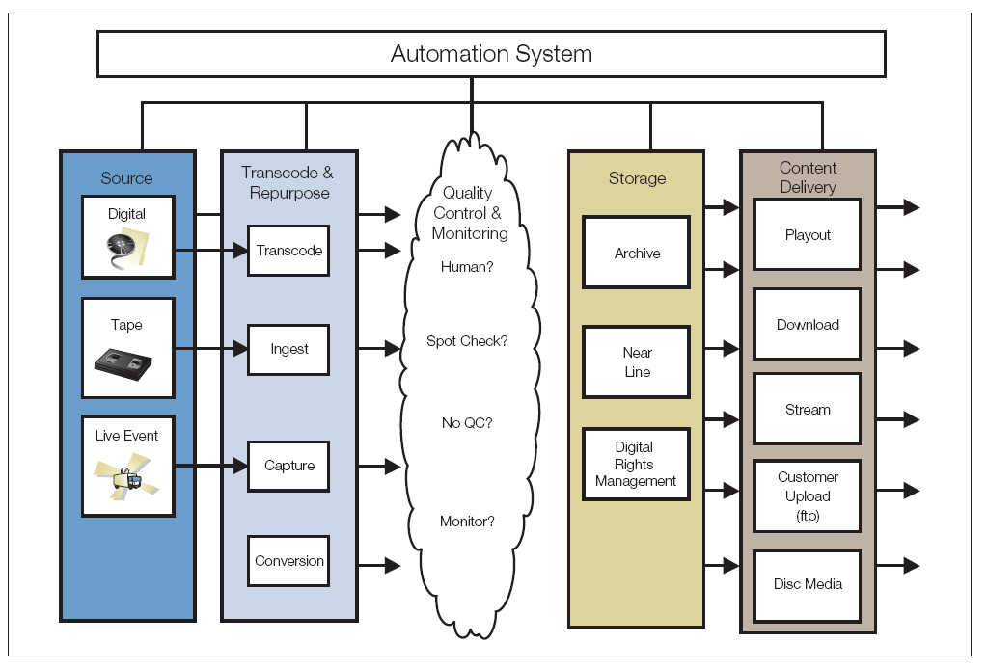
Figure 1. Content interchange workflow.
Content Services – Mezzanine Ingest
Video from a content service provider may follow two or more paths through the steps in the workflow. In the example in Figure 2, the input source might be a tape. The content passes through ingest and then a mezzanine level (high bit-rate digital master like 50 M/bps MPEG-2) is created. Next, the file is transcoded to an end services platform (format) for a client. There might have been visual inspection at the initial ingest process — often watching for tape hits during encoding — but the visual inspection does not show what the encoder is doing. Is the tape being captured correctly? Has the encoder been correctly configured for the tape format? From there, the file is placed into nearline storage.
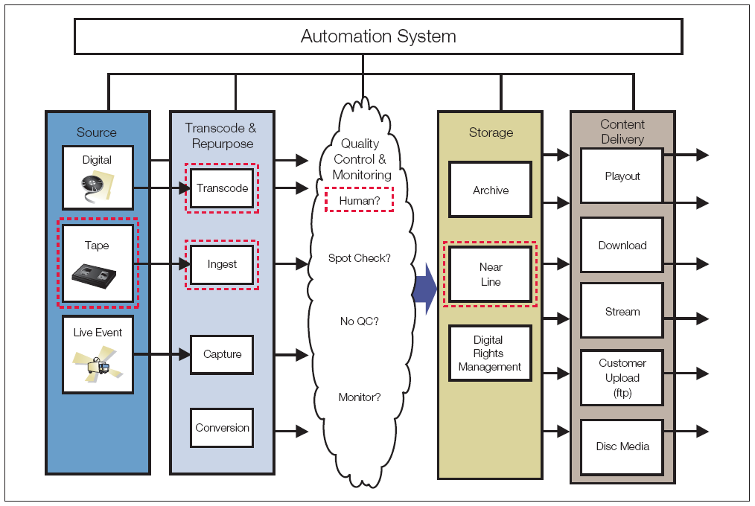
Figure 2. Content interchange workflow with tape source at a content services provider.

In a second path, shown in Figure 3 the input source might also be a digital file. The file is transcoded; visual inspection is a spot check of tops and tails (the beginning and the end). The file is then uploaded by FTP to the client.
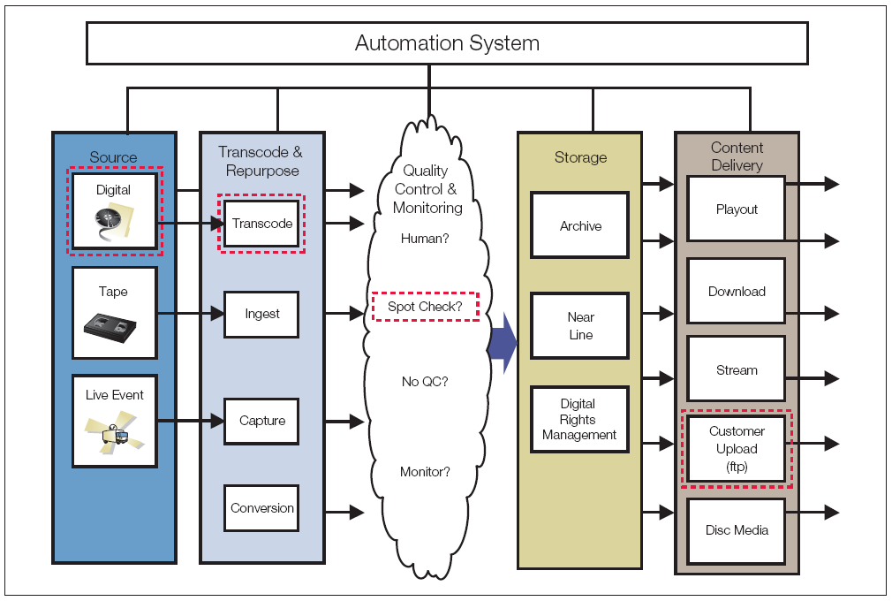
Figure 3. Content interchange workflow with digital source at a content services provider.
The steady growth in content volume has led to transcoding more and more files. This change in transcoding volume has a direct impact on QC strategies. In reality, is there time to QC everything at each step?
A basic assumption is that when the original tape is ingested, complete QC (via visual inspection) is performed and all the errors have already been caught. The problem is that if you don’t catch the errors, the errors end up in all of the transcodes. Then it’s up to the spot check to catch these errors. This can be an expensive process if you catch the errors at the end when it may be too late to re-ingest the original source. As such, 100 percent QC at initial ingest is necessary to prevent the ripple of faulty content downstream. This way, when it comes time for repurposing, the only errors should be the ones introduced during transcoding.
“Churn,” repeating the digital mastering process, is a major cost associated with inadequate QC. Going through this process once, taking a tape to digital file, could include a standards conversion and adding letterboxing and close captioning. Depending upon the cost and time pressure of having the correct file, the number of times that digital mastering is repeated could make the difference between making and losing money.
Content Aggregator – Multiple Transcodes and Streaming
In the example show in Figure 4, the source is a digital file (often transferred in by FTP); it is transcoded, possibly including a standards conversion such as from HD to SD; the QC is 100 percent visual inspection; and the file might go through the QC back-to-transcode loop several times to achieve the required quality. This is because running at such low bit rates, transcodes often don’t work perfectly the first time, especially on fast action sequences. When it looks good enough, it moves to the last step of content delivery, in this case a stream for playout.
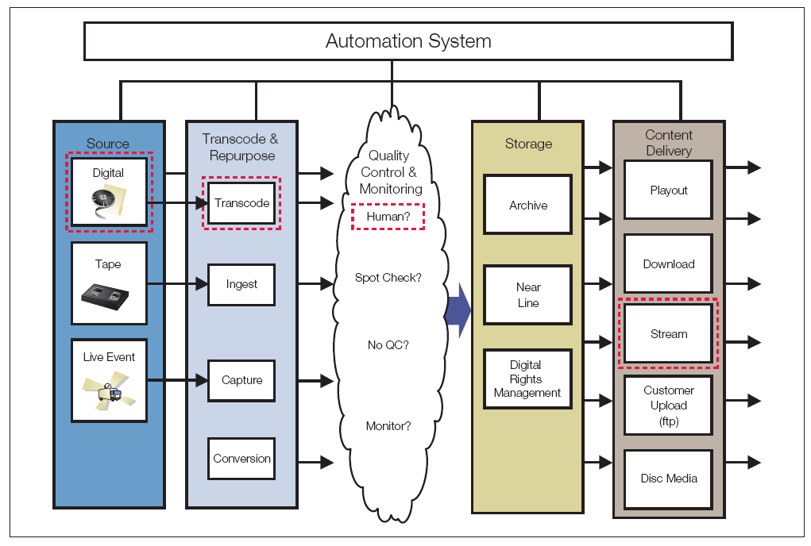
Figure 4. Content workflow for a content aggregator.
Broadcaster – Multiple File Movements
In Figure 5, the source is a tape or live event, which is ingested to a mezzanine format (like MXF MPEG-2). Here, the biggest challenge is the ingest process. There is typically no human QC. And, of course, having to go through the ingest process again on a live event may be impossible. The need for a QC strategy to ensure the file is right the first time, or a way to determine exactly what needs to be addressed, is critical. Lastly the file is sent to nearline storage and from there to playout. Often, the file is moved from nearline or the air server back to archive if it is not to be used again within a certain time frame.
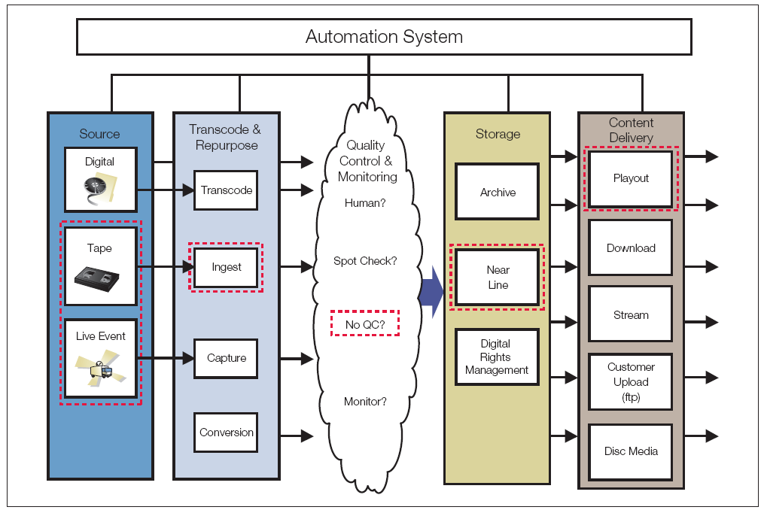
Figure 5. Content interchange workflow for a broadcaster.
In all these examples, doing only visual QC, and just once during the processes, leaves the door open to costly rework or make-goods downstream.
Business Growth and Quality
Broadcast operations are reaching critical mass. The volume of video is multiplying as business units continue to reformat and repurpose video for new revenue streams. Some broadcasters say they are exponentially growing content while only linearly growing QC. And faced with a large growth in channels and services, scaling QC in concert with the increase in content is a difficult challenge. Some potential strategies are:
- Scale down from full QC of all material to perhaps viewing the beginning, middle and end of programs or spot checks.
- Check one program out of 10 (sampling).
- Leave the checking to the next consumer of the content.
The challenge is how to monitor the quality of many new channels when there are different formats and quality levels required for terrestrial, satellite, cable, VoD, and IPTV? Once files have been decoded and re-encoded to a different format, making sure that quality remains intact becomes increasingly difficult. For example, you need a process for checking each different version required for SD/HD, for internal archives, third party licensees and international frame rates. There are a variety of other factors that have an impact on brand quality as a business expands. Here are some examples of real world challenges:
Repurposing – A music channel is straining to fully check only its high bit-rate encoding of incoming master (mezzanine) files, but has not yet found a way to check each different version required for its internal archives, third party licensees, several international versions, VoD, etc.
Time – Sometimes there is just not enough time. A major late-night talk show must be edited and reformatted to be on syndication servers and third party platforms by the very early morning. Even if you can still use people for checking video, you may not be able to hire the right talent at the right time of day.
Another very popular network show is anticipated by its viewers each week. However, for reasons of security, the program is not given to the network until two hours before airing. And the program must be repurposed to the network’s website and other VoD networks within 12 hours.
Scalability – Broadcasters are both centralizing equipment and decentralizing QC. This means, that they want all QC hardware centralized to control costs, but wish to decentralize the place where the work can be done. This frees up expensive real estate and allows more freedom in contracting out QC. Content services companies have work groups all over the world — decentralizing is key.
Automation system integration – Automation systems are constantly improving their ability to track and move files from ingest to playout. QC workflow integration with asset management systems will help make maximum use of your investment and ease scaling — while maintaining consistent quality levels.
Interoperability – You need to make sure that all of the encoding and mastering equipment in your company has the same configuration. There is always a need to monitor equipment configurations like the settings on encoders and decoders.
Establishing a new content vendor – It may take months to get the digital mastering correct for a new VoD system or Web platform. It is important to test your content before it is rejected while online.
Due to the amount of new and repurposed content, content interchange continues to accelerate. Communicating and documenting requirements for file content requirements between content providers and content users can be difficult.
The industry is more broadly starting to embrace the concept of a Content Conformance Agreement (CCA), sometimes called by other names. Many times this is just a verbal agreement, or firms may have a different one for each client. While good in concept, it is not possible to enforce a subjective agreement — especially if there are elements in an agreement that will be missed in visual inspection. To be effective, it has to be objective.
Ideally, checking the file against an agreed-upon CCA would support an automated content filter to evaluate incoming content. Table 1 gives an example of the content parameters in a CCA for correct file configuration and quality of a feature-length movie for full format VoD. Using a CCA could make the difference between content being accepted or rejected both upstream and downstream.
Category | CCA Parameter
Video Standard | MPEG-2
Profile & Level | Main
Play Time | Greater than 60 min.
Horizontal & Vertical Resolution | 720/480
Bit Rate | 3 – 3.5 Mbps
Display/Aspect Ratio | 4:3
Color Depth | 4:2:0
Black frames at start, end or during video | Min 2s black at start  Min 2s black at end
Letterbox and Pillarbox checks | Disallowed
Blockiness | Not greater than 75%
Luma Limit Violation | None

Table 1. CCA for a feature-length movie for full format VoD.
Automated Quality Control
An increasingly popular alternative to the error-prone manual process of visually inspecting video content, is an automated system for conducting a thorough check of video files. Such a system, as shown in Figure 6, can check all aspects of content including compliance/correctness to video and audio standards, video formats, resolutions, bit rates, adherence to transmission system limits as well as video and audio quality (including black frames, blockiness and audio silence).
These systems are integrated into a network and able to automatically check the correctness of file-based content against defined standards at many stages. The multiple levels of testing mean content will play, can be transmitted, is technically legal and has good quality.

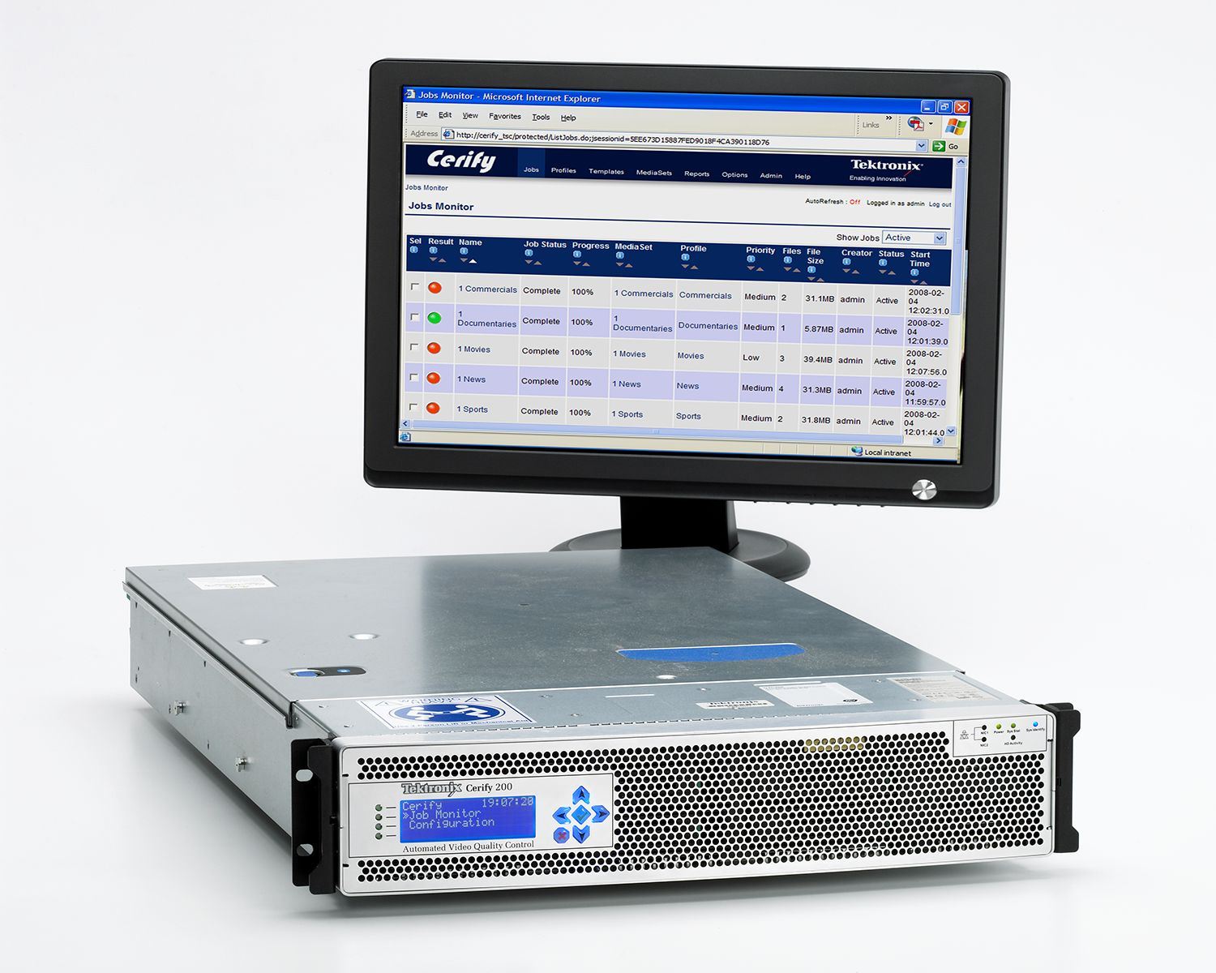
Figure 6. Tektronix Cerify CYS100 can be use for automatic 24/7 quality control of file-based video content.
Conclusion
While the interchange of content continues to grow exponentially, visually inspecting program content fails to identify costly problems. In fact, visual inspection of incoming file-based video content as a means of QC is not comprehensive, fast or scalable.
Server-based, automated file verification provides a content filter that can catch the errors that people would normally miss, and provides a way to uniformly check the conformance of content. A specific content filter with your unique program requirements can be used to establish a CCA with content suppliers and customers. Documented CCA results can reduce rejected content, create an audit trail and increase the quality of content viewed by the consumer.
###

About the Author
Jon P. Hammarstrom is Senior Manager of Global Marketing for Video at Tektronix where he is responsible for Tektronix strategic market planning and outbound marketing programs. Prior to joining Tektronix in May 2004, Hammarstrom held a variety of senior management positions with video equipment manufacturers and software development organizations. He has been part of numerous pioneering product and technology introductions in the worldwide broadcast video marketplace.
Author email: jon.p.hammarstrom@tektronix.com

